**Integrate Printer Scanner into the e-Dokyu**

1. Open Linux CLI console by simultaneously pressing “ctrl + alt + f1” or “ctrl + alt + f3”.
2. Type in: ‘root’ for username and ‘p@ssword123’ for password
3. Edit ‘smb.conf’ under ‘/etc/samba/’. To do this, invoke the command: ‘nano /etc/samba/smb.conf’ and encode the following configuration to share the ‘incoming-temp’ of the e-dokyu web app.

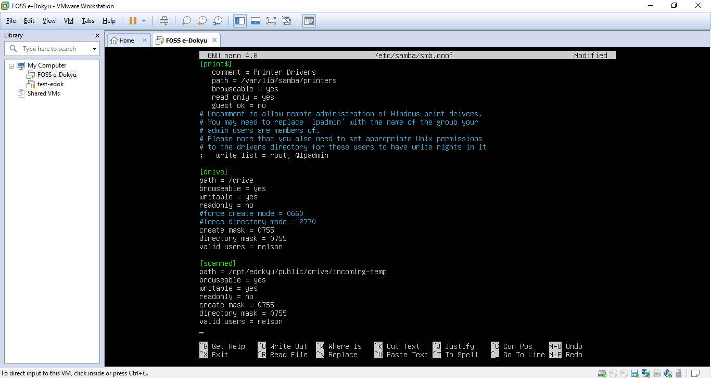

1. Add SMB user account and change ownership of the ‘incoming-temp’ folder:
   1. Type ‘smbpasswd –a nelson’ and press enter. Type-in the password
   2. Type ‘chown nelson:root /opt/edokyu/public/drive/incoming-temp/’

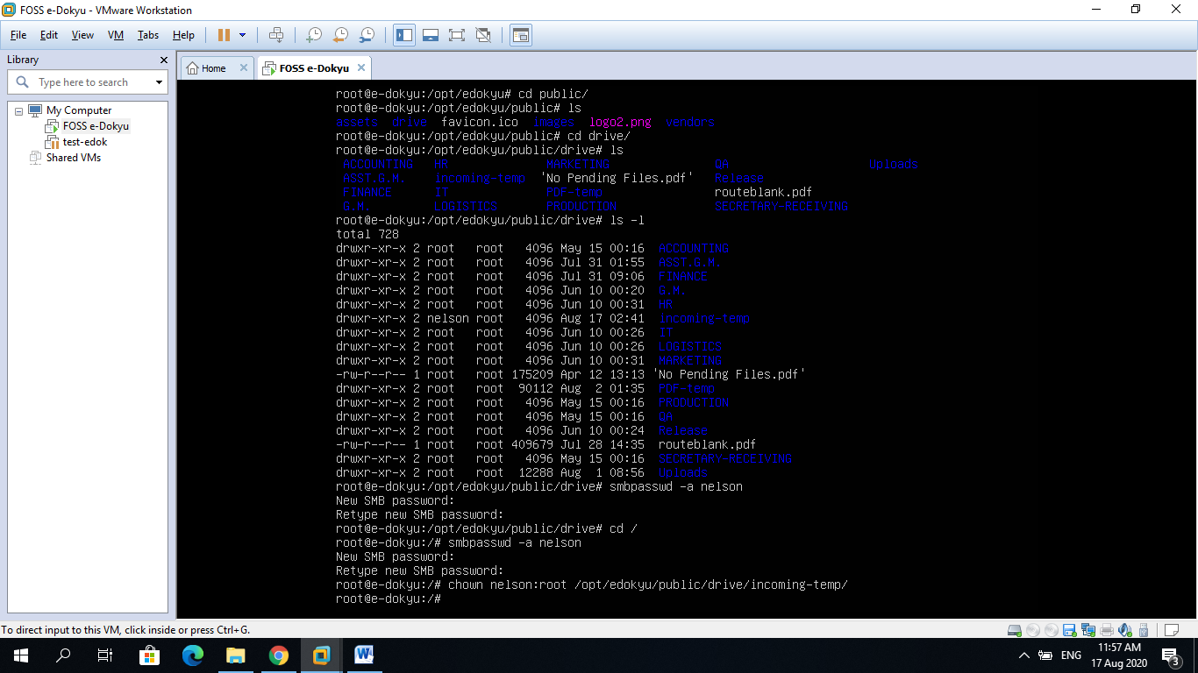

1. Restart samba service: ‘service smbd restart’ or restart the machine.
2. Test the shared drive:

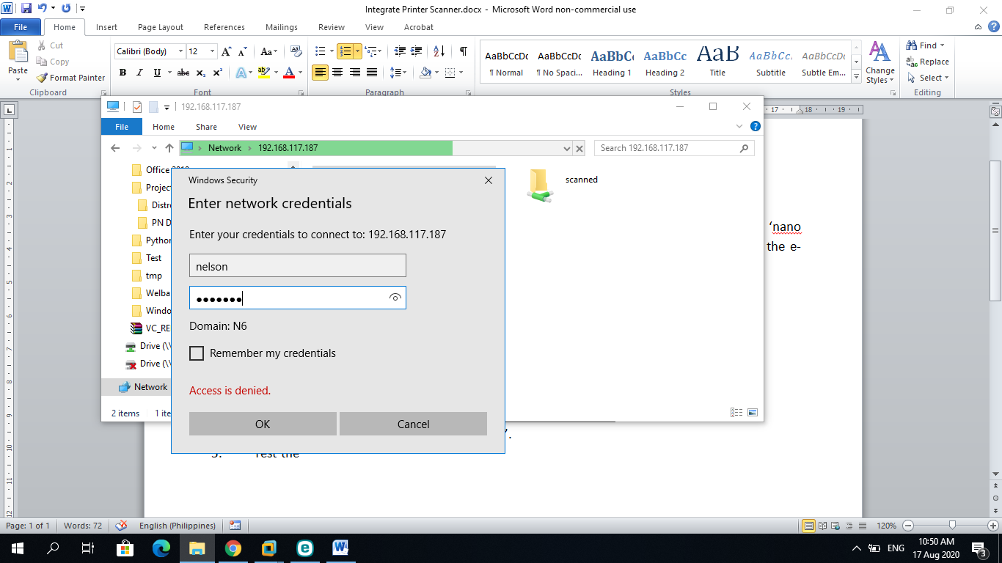

1. Configure your printer scanner and add SMB network address for scanned documents. Below is an example:

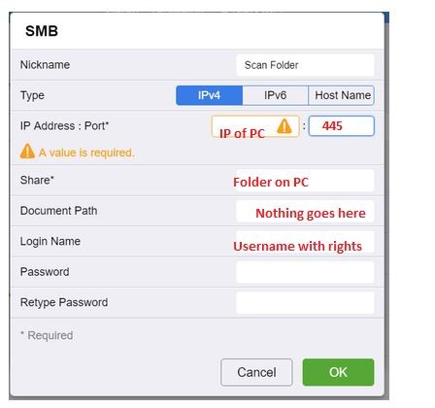

1. Test scan a document.
2. Login to e-Dokyumento as ‘staff-secretary’ with password ‘staff@123’. Only accounts with ‘SECRETARY-RECEIVING’ can view scanned documents.

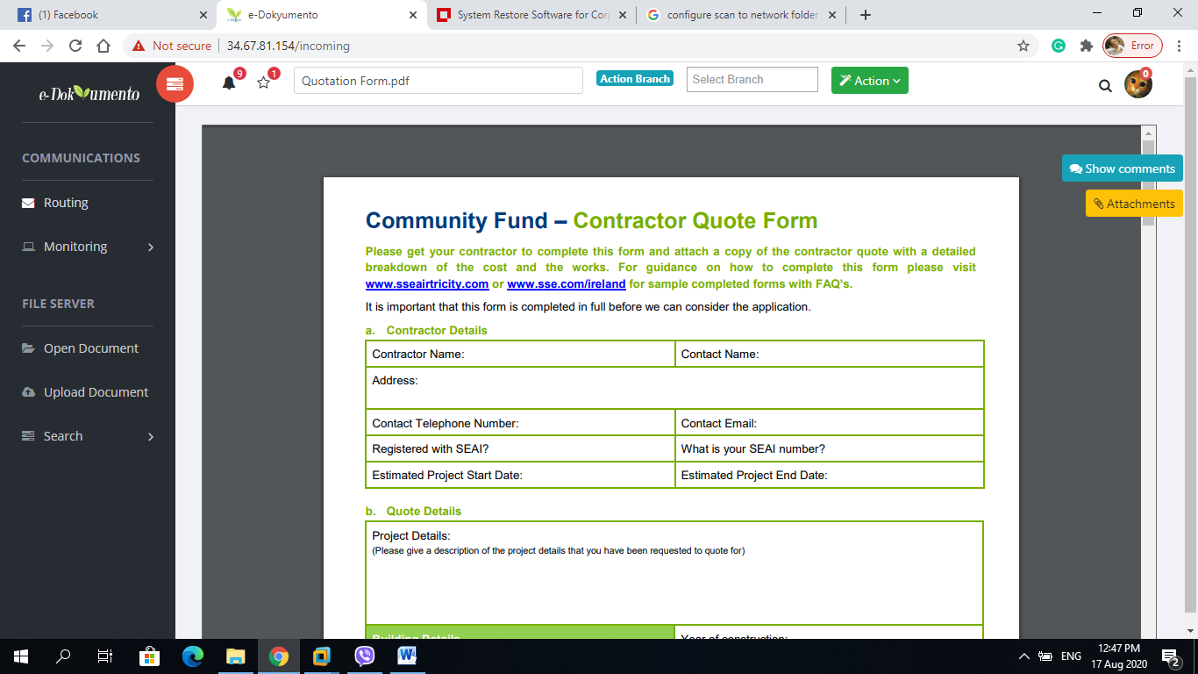

Scanned documents